Have We Found the Lost Colony of Roanoke Island?

Remote-sensing techniques have unearthed clues to the fate of settlers who mysteriously disappeared.
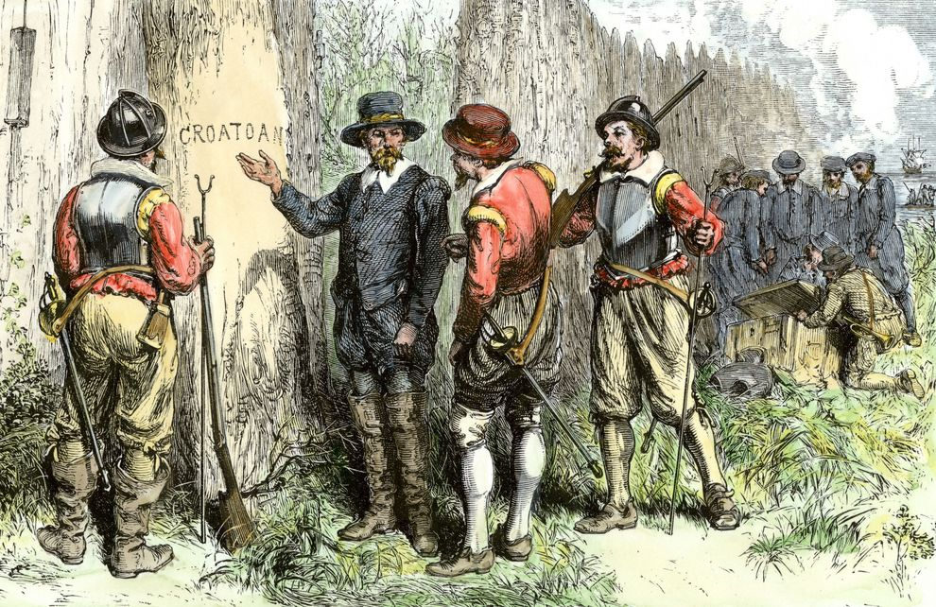
Roanoke Colony was found abandoned without a trace of the colonists—but some researchers might have uncovered some clues.
ILLUSTRATION BY NORTH WIND PICTURE ARCHIVES/ALAMY
Tanya Basu
National Geographic
PUBLISHED DECEMBER 6, 2013
It's a mystery that has intrigued Americans for centuries: What happened to the lost colonists of North Carolina's Roanoke Island? (See "America's Lost Colony.")
More »
The settlers, who arrived in 1587, disappeared in 1590, leaving behind only two clues: the words "Croatoan" carved into a fort's gatepost and "Cro" etched into a tree.
Theories about the disappearance have ranged from an annihilating disease to a violent rampage by local Native American tribes. Previous digs have turned up some information and artifacts from the original colonists but very little about what happened to them.
Until now.
Thanks to technological advances and a cover-up on a map, researchers are getting closer to finding out what happened to the lost colony of Roanoke Island.
What Do We Know?
The lost colonists were the third group of English arrivals on North Carolina’s Roanoke Island, settling near the modern-day town of Manteo.
The first group to arrive, in 1584, came to explore and map the land for future groups. A second group, which arrived in 1585, was charged with a military and scientific mission. But this second group's trip was far from peaceful.
"That's where tensions begin [with the local Native American tribes]," said Clay Swindell of the Museum of the Albemarle in Elizabeth City, North Carolina, a member of the archaeology team investigating the colony. He says that this second group was driven out in 1586 by local tribes angry that the colonists were taking up good land and resources.
The third group arrived in 1587. Entire families came with children—17 women and 11 children accompanied a party of 90 men. That meant the group wanted to settle in the New World and was not a military excursion, which would have included only male explorers.

A Map With Secrets
A clue uncovered in a long-forgotten, centuries-old map of the area called "La Virginea Pars"—drawn by the colony's governor John White—kicked off a reexamination of the fate of the lost colonists. An artist and employee of explorer Sir Walter Raleigh, White was later appointed governor of the new lands; he was also the grandfather of Virginia Dare, the first English child born in the New World.
Two patches on the map made Brent Lane of the First Colony Foundation (the group behind the latest archaeological trip and whose work is supported by National Geographic and the Waitt Grants Programs) in Durham, North Carolina, wonder if they might hide something beneath.
Scientists at the British Museum looked into the patches and discovered a tiny red-and-blue symbol. Could it have indicated a fort or a secret emergency location?
"Our best idea is that parts of Raleigh's exploration in North America were a state secret, and the map 'cover-up' was an effort to keep information from the public and from foreign agents," said Eric Klingelhofer of Mercer University in Macon, Georgia, a historian and the principal investigator on the project.
Disappearing Act
Most researchers think the colonists likely encountered disease—caused by New World microbes their bodies had never encountered before—or violence.
The research team thinks that when the crisis—whatever that may have been—hit, the colonists split up into smaller groups and dispersed.
"It's a good strategy," he said, explaining that the previous group from 1585 had been ordered to do so if disaster struck. "We don't definitely know that they do, but it's obvious that that's the only way they could have survived. No single Indian tribe or village could have supported them. They would be even larger than some villages—I mean, they were over a hundred people."
The prevailing theory has been that the colonists abandoned Roanoke and traveled 50 miles south to Hatteras Island, which was then known as Croatoan Island. But, Klingelhofer said, what if they went in another direction?
What if some of the colonists traveled west via Albemarle Sound to the mouth of the Chowan River, to a protected inlet occupied by a sympathetic tribe? (See "What 'Sleepy Hollow' Didn't Tell Us About Roanoke's Lost Colony.")
Furthermore, archaeologists have identified the nearby site of a small Native American town named Mettaquem, which may have adopted some of the colonists. Klingelhofer said that while researchers don't know much about the Native American town and its inhabitants, its existence has been verified.
"It's a very strategic place, right at the end of Albemarle Sound," he said. "You can go north up the Chowan River to Virginia or west to the Blue Ridge Mountains. They were big trading partners" with other Native American tribes.

Now that you have read the theories, create a 2 paragraph paper (at least 10 sentences) describing what you believe happened to the colonists at Roanoke.

