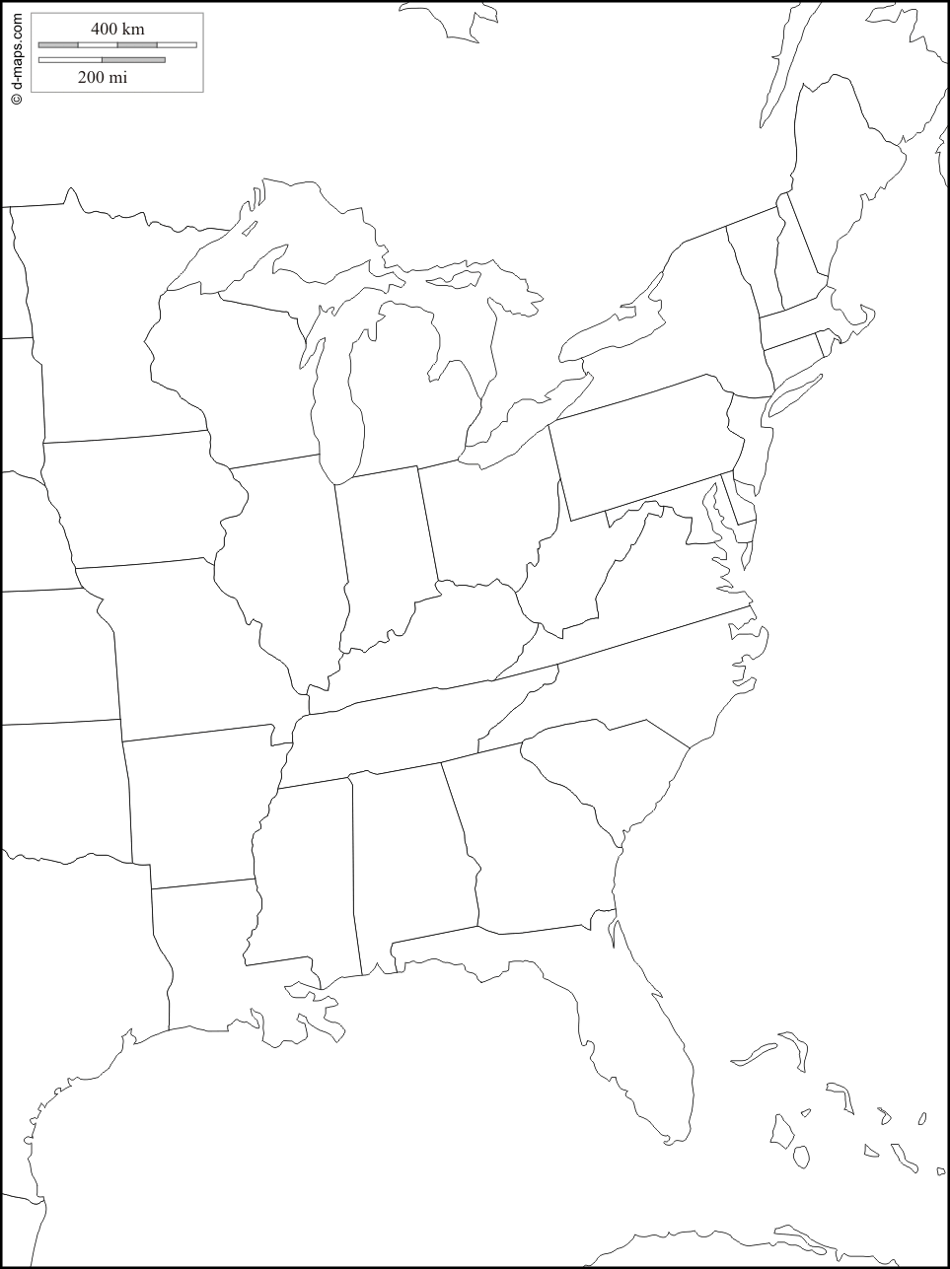
Find, Label, and Draw the following features

1. Lake Superior 2. Lake Michigan 3. Lake Huron 4. Lake Erie 5. Lake Ontario 6. Gulf of Mexico

7. New England Region 8. Mid-Atlantic Region 9. Southeast Region 10. Midwest Region 11. The St. Lawrence Seaway

12. The Mississippi River 13. The Appalachian Mountains 14. Coastal Plains 15. Ohio River 16. Atlantic Ocean

